**Docker Task -2**

**Task Description:**

Create a dockerfile, docker-compose file which when executed must display your basic details in the website.

**Techstacks needs to be used :**

* AWS EC2
* Docker

**Output Screenshots:**

1)Launch EC2 Instance

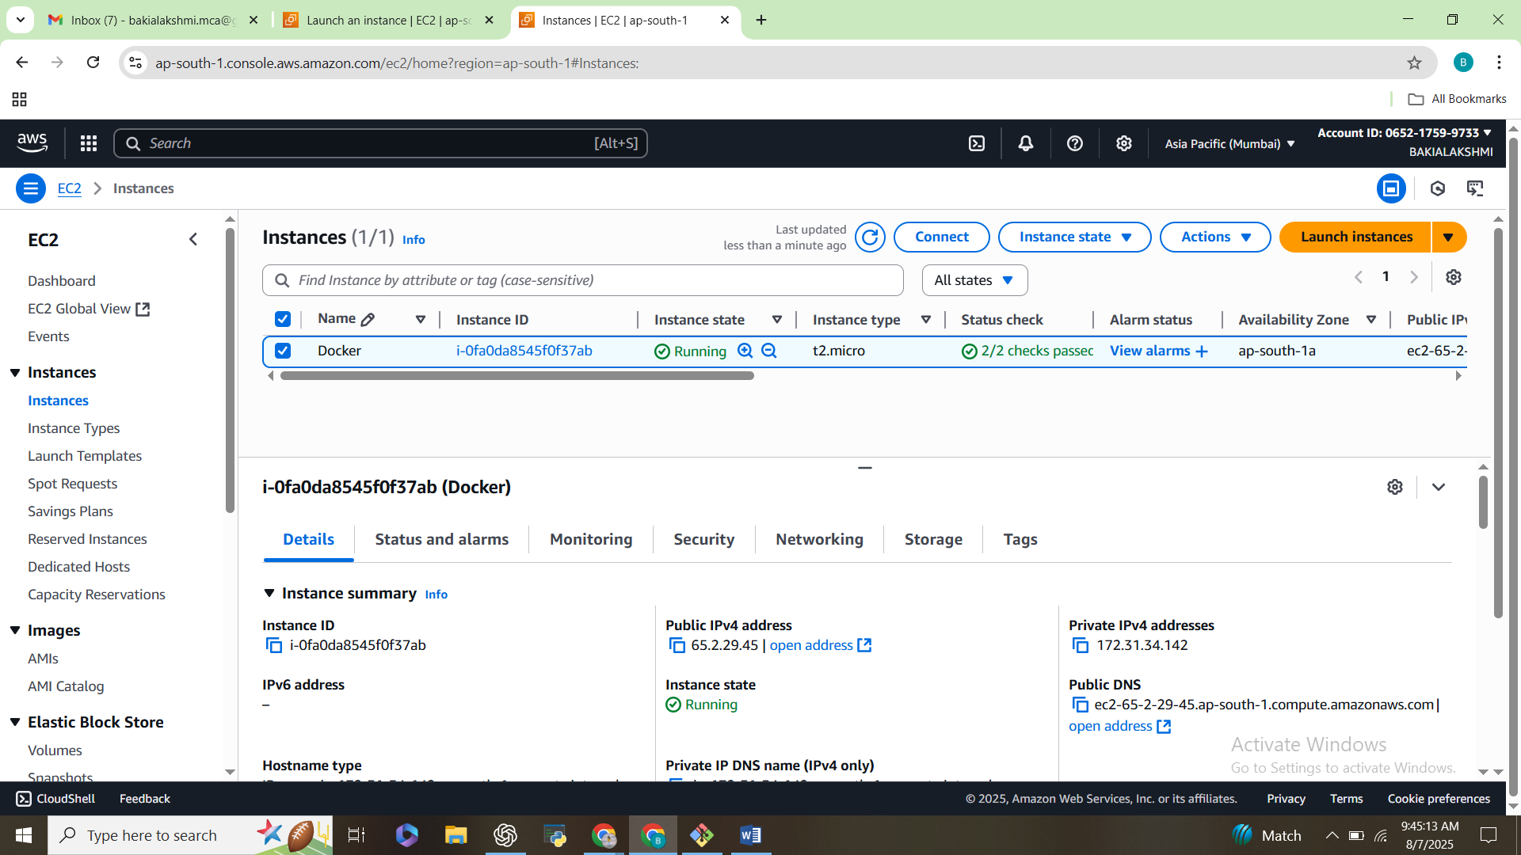

2)Install Docker & Docker Compose

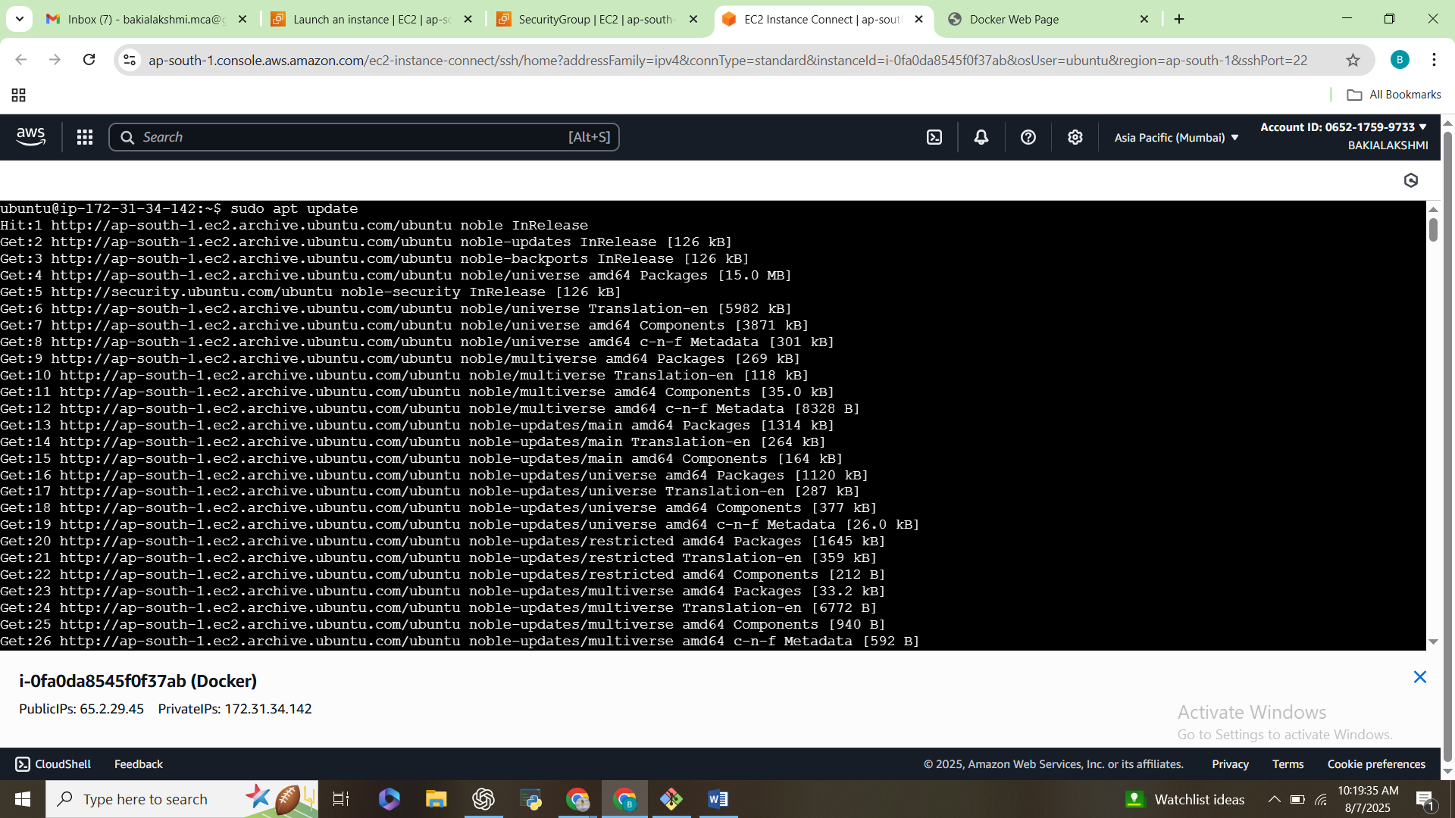

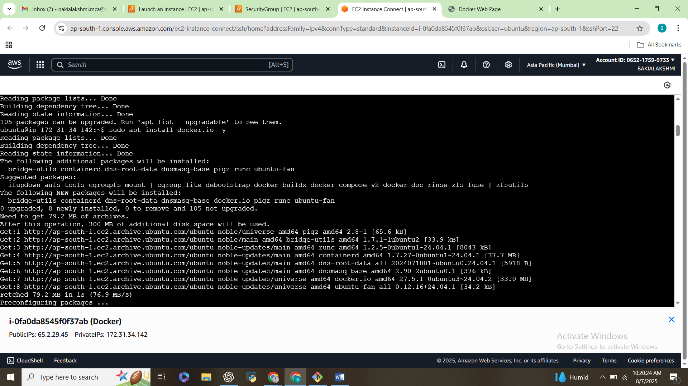

3) Docker Compose

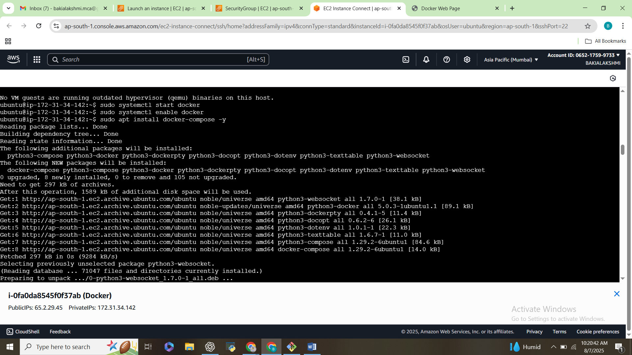

4)Create Project Folder & Files

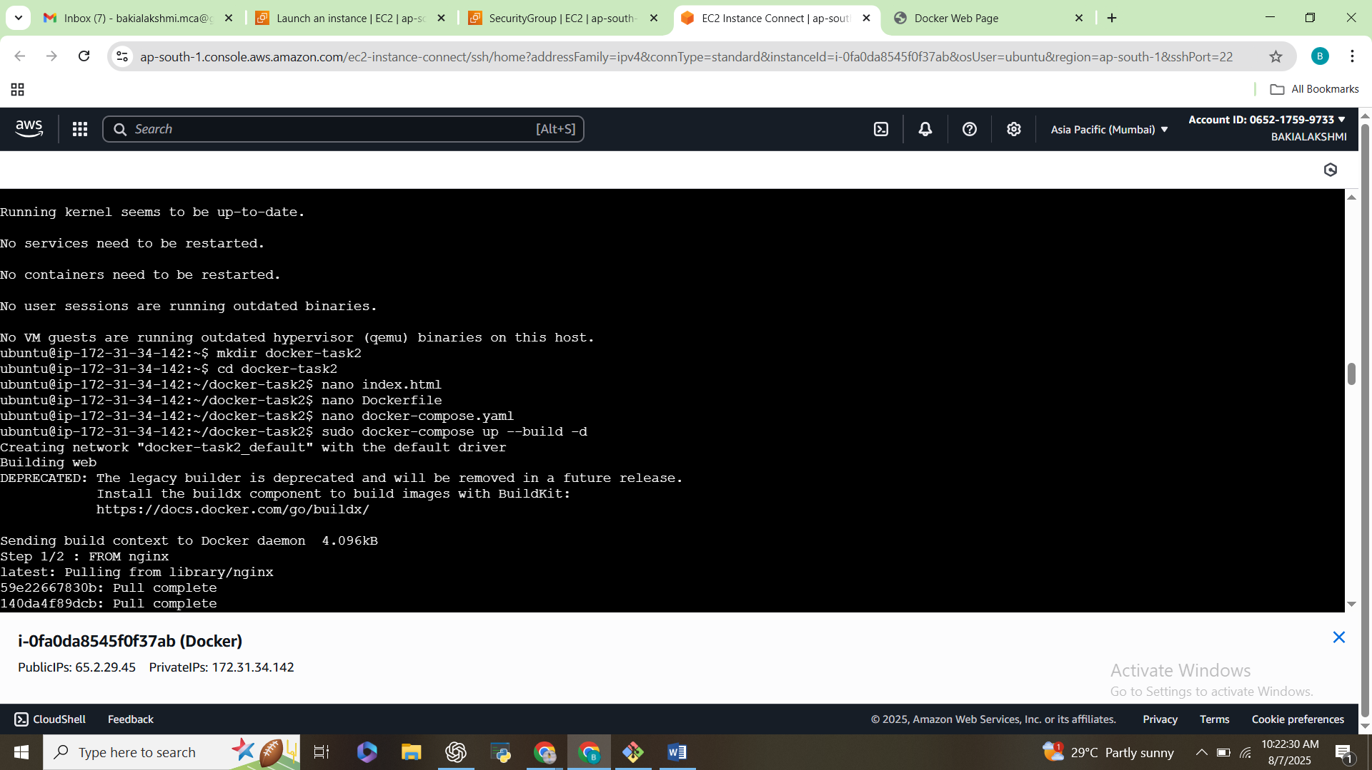

5)index.html

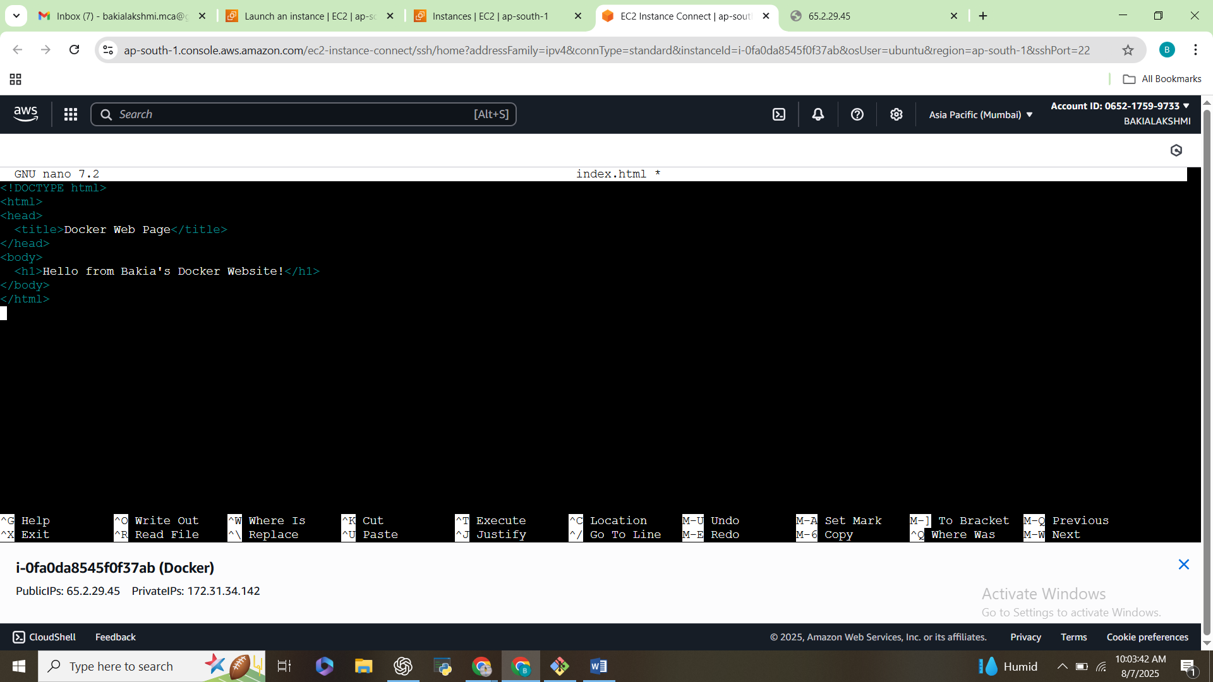

6) Dockerfile

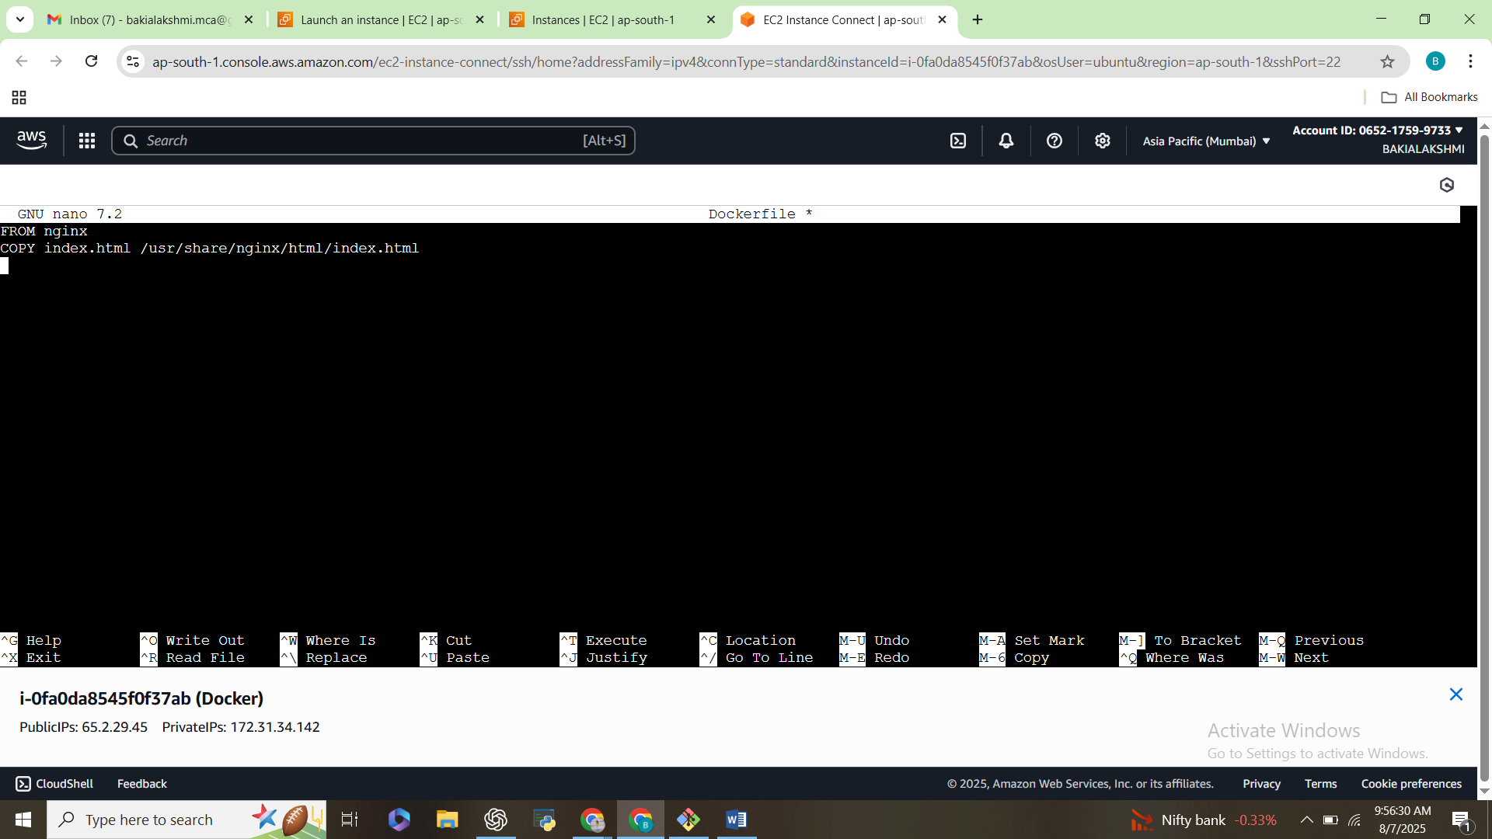

7)Build & Run using Docker Compose

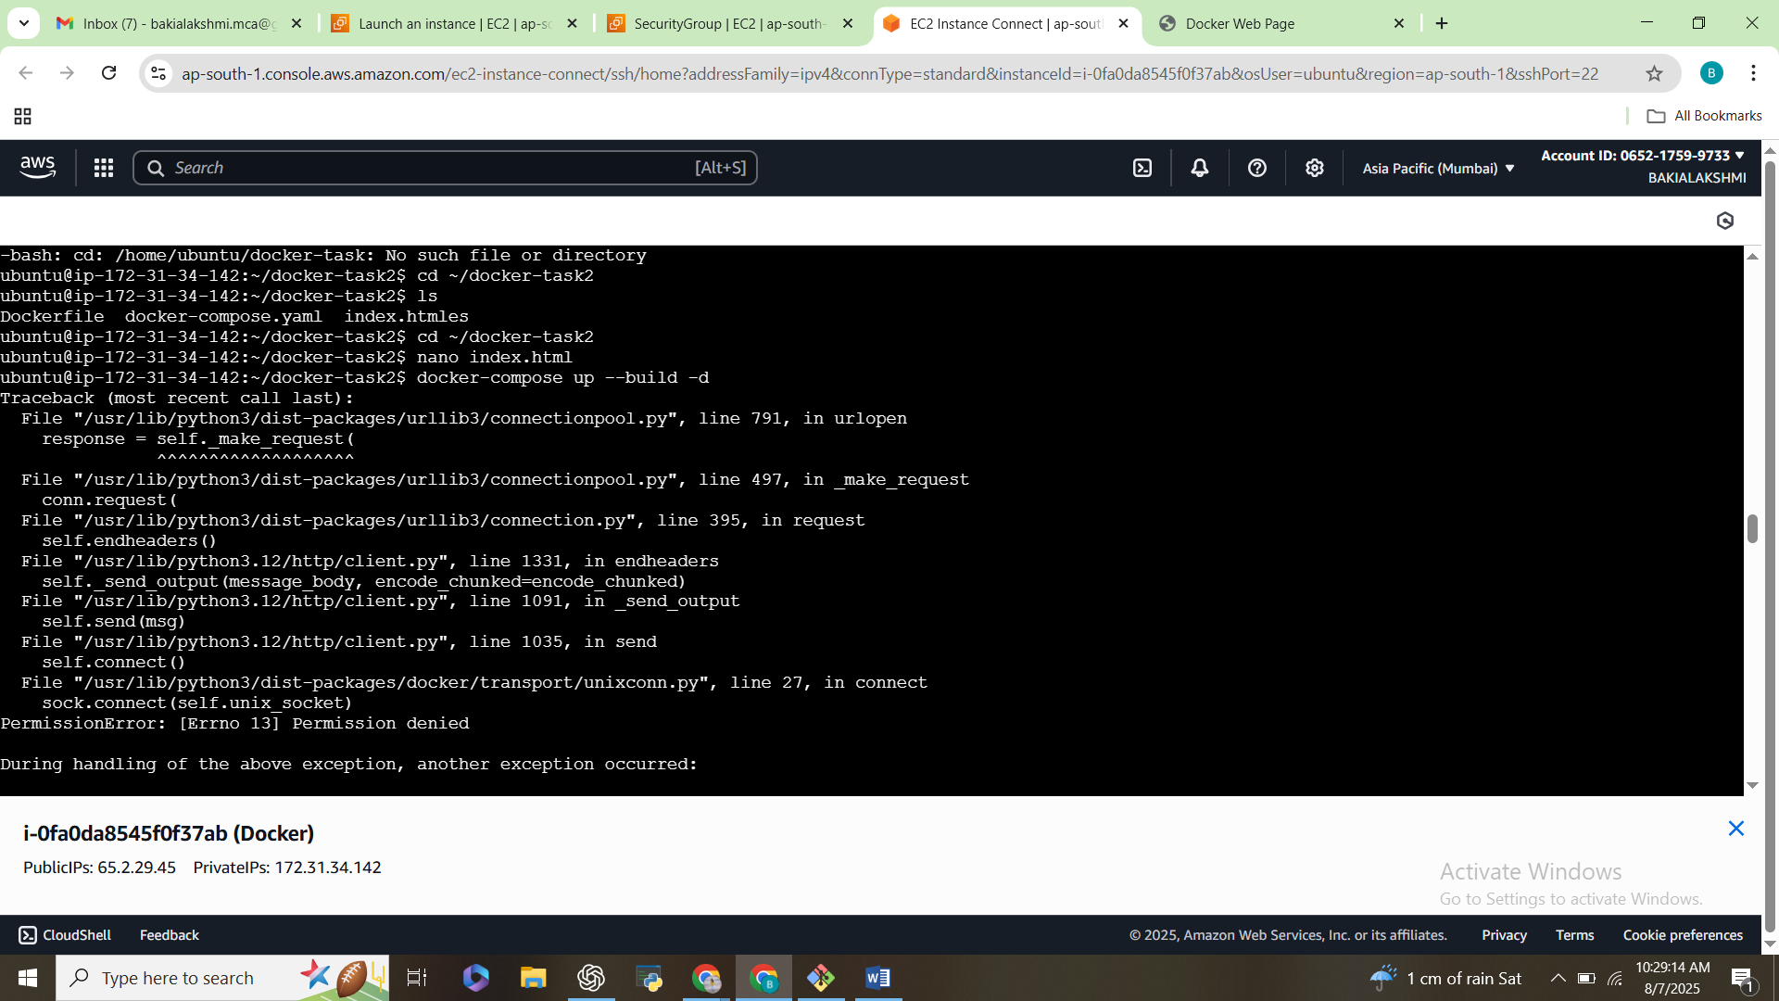

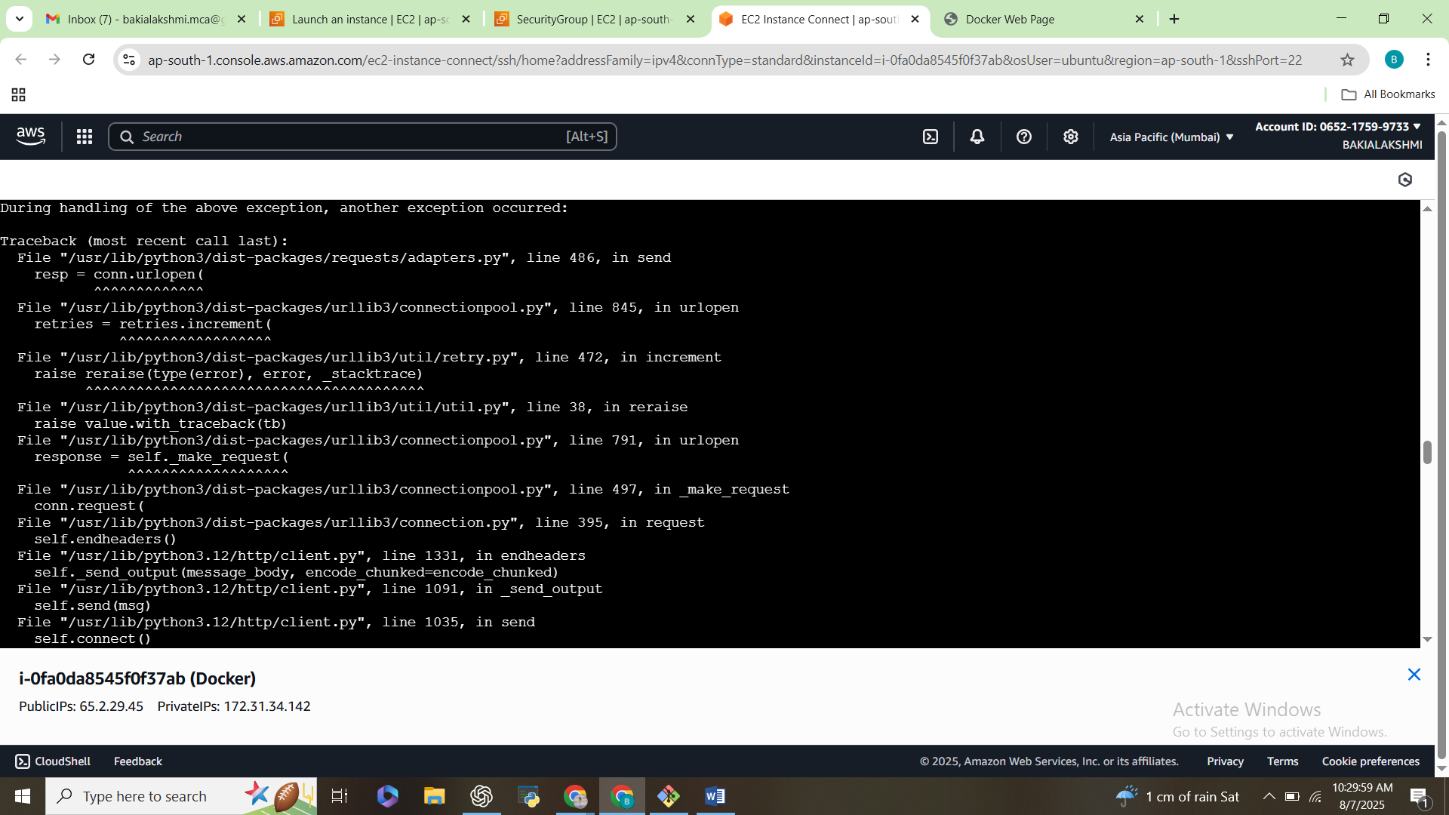

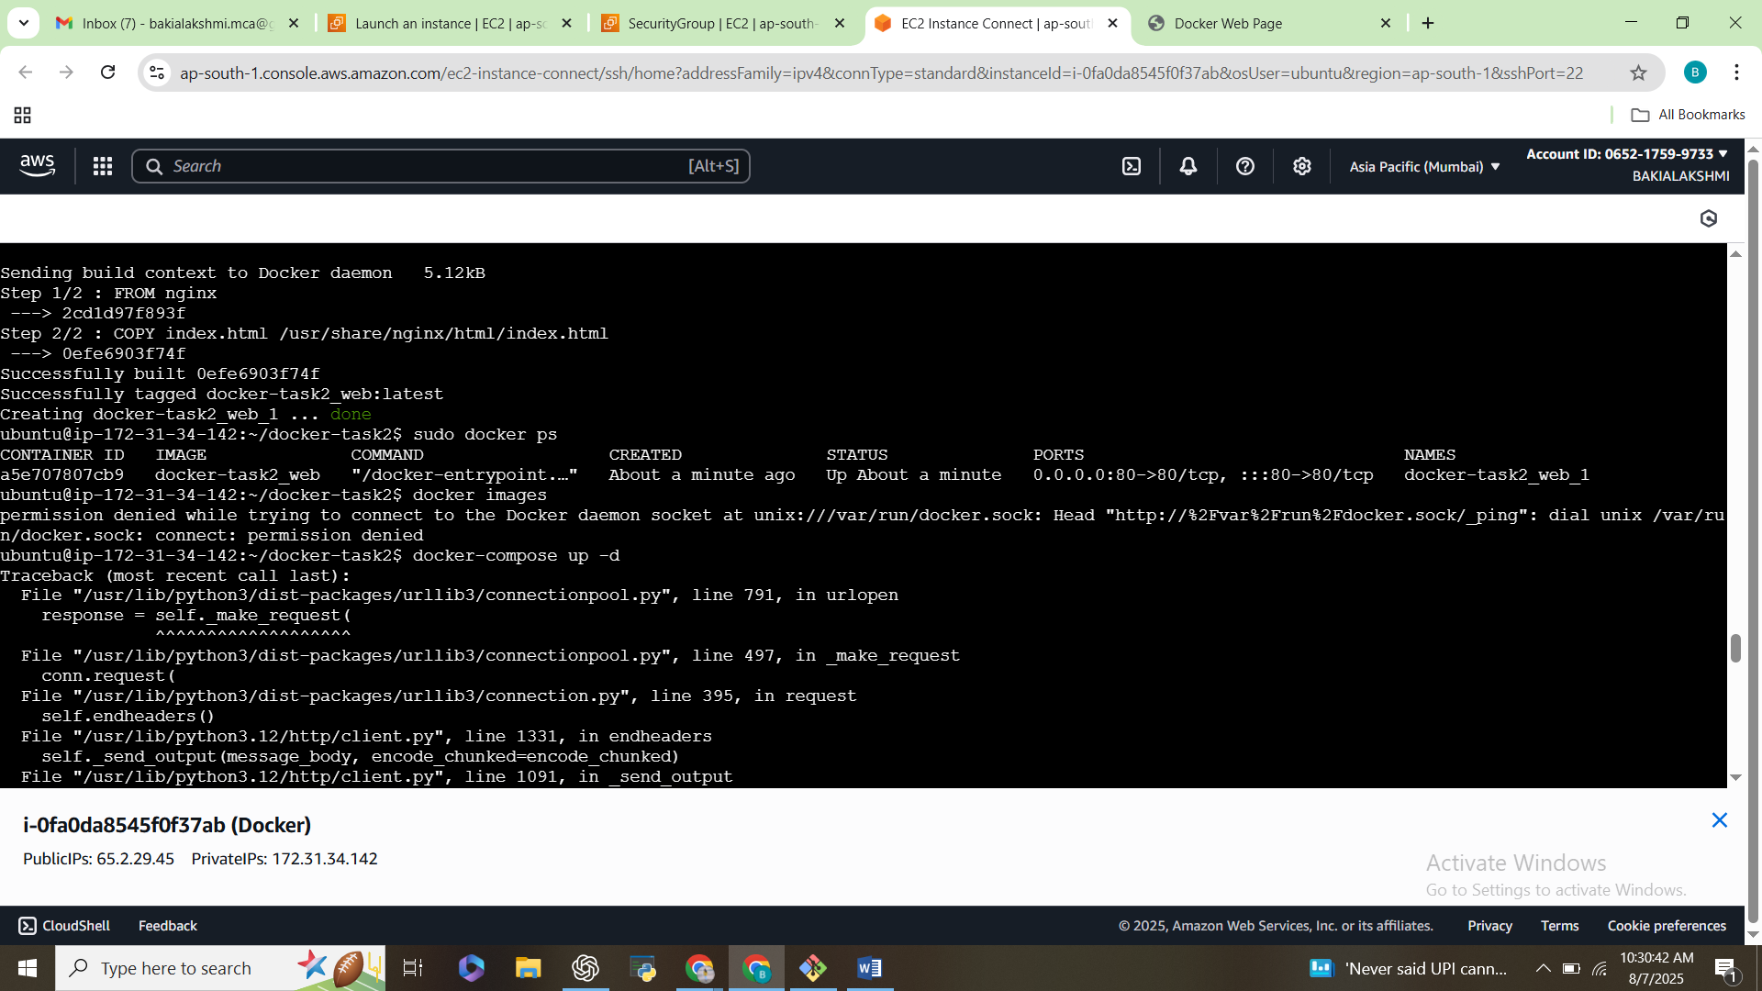

8)Website

